Game Software Requirement

-IDE :- Unity 5.6.2

Download Link :- <https://store.unity.com/download?ref=personal>

Installation Steps :- 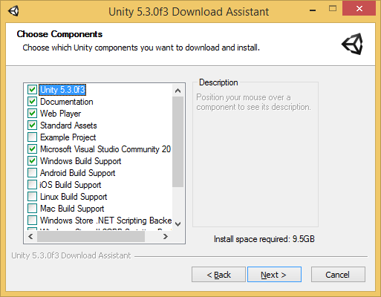

-Select Example Project , Android Build Support , IOS Build Support

-Visual Studio 2017 Community

Download Link :- <https://www.visualstudio.com/downloads/>

-Android SDk 2.3.3

Download Link :- <https://developer.android.com/studio/index.html>

-JDK 8

Download Link :- <http://www.oracle.com/technetwork/java/javase/downloads/jdk8-downloads-2133151.html>

Set up Android SDK and JDK in Unity :-

<https://unity3d.com/learn/tutorials/topics/mobile-touch/building-your-unity-game-android-device-testing>

Game Made In Unity:-

<https://madewith.unity.com/>